Question 5

(a)

(1). if there is only one rolls, expected value is

$$\frac{1}{6}*1+\frac{1}{6}*2+\frac{1}{6}*3+\frac{1}{6}*4+\frac{1}{6}*5+\frac{1}{6}*6$$

$$=3.5$$

(2). If there are two throws, the expected value for each throw is 3.5. Therefore, only when the result of the first throw is 1,2, or 3, I will throw the second time, whose expected value is 3.5. The expected value is

$$\frac{1}{6}*4+\frac{1}{6}*5+\frac{1}{6}*6+$$

$$\frac{1}{6}*\left(\frac{1}{6}*1+\frac{1}{6}*2+\frac{1}{6}*3+\frac{1}{6}*4+\frac{1}{6}*5+\frac{1}{6}*6\right)*3$$

$$=4.25$$

The diagram below illustrates the calculation above.

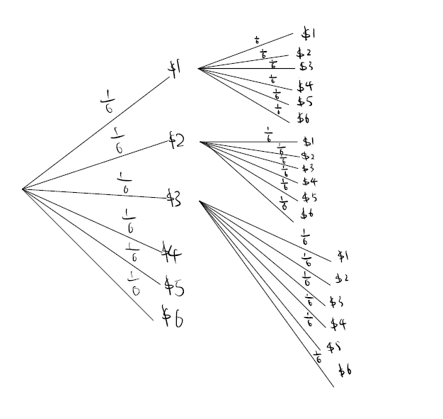

(3). If there are three throws, the expected value of the second and third throw is 4.25. Therefore, only when the result of the first throw is 1,2,3 or 4, I will throw the second time. The expected value of the third throw is 3.5. Therefore, only when the result of the second throw is 1,2, or 3, I will throw the third time. Therefore, the expected value is

$$\frac{1}{6}*5+\frac{1}{6}*6+$$

$$\frac{1}{6}*\left(\frac{1}{6}*4+\frac{1}{6}*5+\frac{1}{6}*6\right)*4+$$

$$\frac{1}{6}*\frac{1}{6}*\left(\frac{1}{6}*1+\frac{1}{6}*2+\frac{1}{6}*3+\frac{1}{6}*4+\frac{1}{6}*5+\frac{1}{6}*6\right)*12$$

$$= 4.67$$

The diagram for this calculation is too complicate to be draw by hand. However, the idea is same as part (2) above.

Therefore, if I am risk-neutral, the fair value of this game to me is $4.67.

(b)

Since I am risk averse, I prefer outcomes with low uncertainty to those outcomes with high uncertainty. I will use log (base 10) utility to calculate the expected value of the fair game.

First, calculating the log value of all possible payoff:

$$\log\left(1\right)=0,\log\left(2\right)=0.301,\log\left(3\right)=0.477,\log\left(4\right)=0.602,\log\left(5\right)=0.698,\log\left(6\right)=0.778$$

(1). if there is only one rolls, expected value is

$$\frac{1}{6}*\log\left(1\right)+\frac{1}{6}*\log\left(2\right)+\frac{1}{6}*\log\left(3\right)+\frac{1}{6}*\log\left(4\right)+\frac{1}{6}*\log\left(5\right)+\frac{1}{6}*\log\left(6\right)$$

$$=0.476$$

(2). If there are two throws, the log of expected value for each throw is 0.476. Therefore, only when the result of the first throw is 1 or 2, I will throw the second time. Therefore, the expected value is

$$\frac{1}{6}*log⁡(3)+\frac{1}{6}*log⁡(4)+\frac{1}{6}*log⁡(5)+\frac{1}{6}*log⁡(6)+$$

$$\frac{1}{6}*\left(\frac{1}{6}*\log\left(1\right)+\frac{1}{6}*\log\left(2\right)+\frac{1}{6}*\log\left(3\right)+\frac{1}{6}*\log\left(4\right)+\frac{1}{6}*\log\left(5\right)+\frac{1}{6}*log⁡(6)\right)*2$$

$$=0.585$$

(3). If there are three throws, the expected value of the second and third throw is 0.585. Therefore, only when the result of the first throw is 1,2 or 3, I will throw the second time. The expected value of the third throw is 0.476. Therefore, only when the result of the second throw is 1 or 2, I will throw the third time. Therefore, the expected value is $$\frac{1}{6}*\log\left(4\right)+\frac{1}{6}*log⁡(5)+\frac{1}{6}*log⁡(6)+$$

$$\frac{1}{6}*\left(\frac{1}{6}*\log\left(3\right)+\frac{1}{6}*\log\left(4\right)+\frac{1}{6}*log⁡(5)+\frac{1}{6}*log⁡(6)\right)*3+$$

$$\frac{1}{6}*\frac{1}{6}*\left(\frac{1}{6}*\log\left(1\right)+\frac{1}{6}*\log\left(2\right)+\frac{1}{6}*\log\left(3\right)+\frac{1}{6}*\log\left(4\right)+\frac{1}{6}*\log\left(5\right)+\frac{1}{6}*\log\left(6\right)\right)*6$$

$$=0.664$$

We could convert the 10 base log form to the original form:

$${10}^{0.664}=4,61$$

Therefore, if I am risk-averse, the fair value of this game to me is $4.61.